Evidence of Tanking in the NBA

Is tanking in the NBA Real?

In the NBA, the teams with the worst records at the end of each year have the highest chance of securing a valuable pick in the upcoming summer draft. As a result, there is an incentive for some teams to lose many games in a season in hopes of securing a talented player in the draft. This strategy of purposely losing to secure future talent is called ‘tanking.’

Is there statistical evidence that tanking occurs in the NBA? One way to answer that question is to compare the actual distribution of how many wins each team accrues during an 82-game season with a normal distribution, which would represent the expected distribution of accrued wins throughout a season. The graph below compares the expected and actual distributions of teams able to secure at least a certain number of wins during the 2018-2019 NBA season.

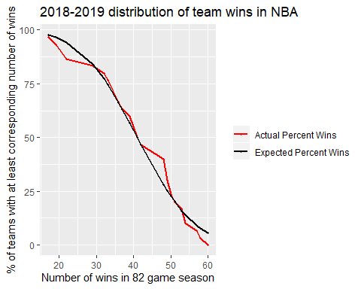

We can see that the actual distribution follows the normal distribution somewhat closely, giving credence to the idea that team wins in a season are normally distributed. However, there are a few places where the actual distribution differs from the normal distribution:

1. Fewer teams win at least 20-30 games in a season than the normal distribution would predict.

2. More teams win at least 44-49 games in a season than the normal distribution would predict.

3. Fewer teams win more than 51 games in a season than the normal distribution would predict.

A look at the past five seasons of NBA records show that similar results hold.

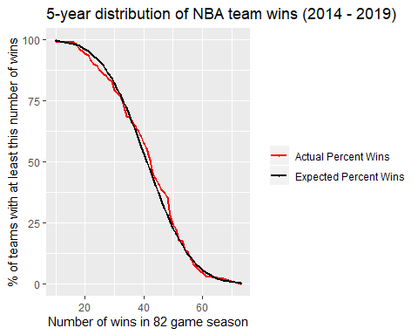

Another way to look at this result is to plot the residual, or the difference between the two lines above (the difference between the normal distribution and the actual distribution).

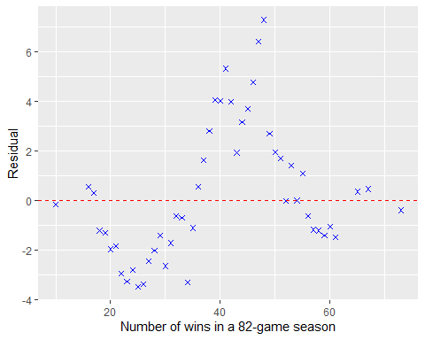

We can see that in the past five years,

1. Fewer teams win at least 18-36 games than we would expect.

2. More teams win at least 37-50 games than we would expect.

3. Fewer teams win at least 55-61 games than we would expect.

The fact that fewer teams win at least 18-36 games than we would expect is suggestive that tanking is indeed taking place to some extent in the NBA. If fewer teams are winning than expected at one part of the distribution, there must be another part of the distribution that compensates for this. We find the compensatory effect in the 37-48 wins per season range. A reason why we see that more teams win 37-48 games per season than expected could be because teams in this win range are often competing for a playoff spot. For teams in this win range, every win matters all season long. In contrast, very bad teams will not make the playoffs even if they accrue a few extra wins at the end of the season and very good teams will make the playoffs even if they slip up in a few games.

The fact that fewer teams win at least 55-61 games than expected may be a result of decreasing marginal returns on winning during an NBA season. If an NBA team wins more than 55 games in the season, the team is almost certainly guaranteed a spot in the playoffs. At the end of the season, these teams may rest some of their star players to conserve their best performances for the playoffs.

\*Data from basketballreference.com.